24-08-2026

EXPERIMENT 24 – FAMILY TREE

AIM
To write a Prolog program to implement a family tree and determine family relationships.

ALGORITHM
- Start the program.
- Define parent, male, and female facts.
- Define rules for father and mother.
- Define rules for sibling and grandparent.
- Query and display the required family relationship.

PROGRAM
parent(ravi, aseem).
parent(ravi, priya).
parent(meena, aseem).
parent(meena, priya).

parent(aseem, rahul).

male(ravi).
male(aseem).
male(rahul).

female(meena).
female(priya).

father(X, Y) :-
parent(X, Y),
male(X).

mother(X, Y) :-
parent(X, Y),
female(X).

sibling(X, Y) :-
parent(P, X),
parent(P, Y),
X \= Y.

grandparent(X, Z) :-
parent(X, Y),
parent(Y, Z).

OUTPUT

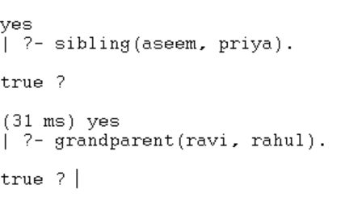

RESULT
Thus, the family tree was successfully implemented using Prolog.

